Superhero Movies: Here to Stay?
Superhero movies have become a big part of box office and cinematic success with gripping storylines and impossible feats, lovable heroes and chilling villains. But are they going to stay popular?

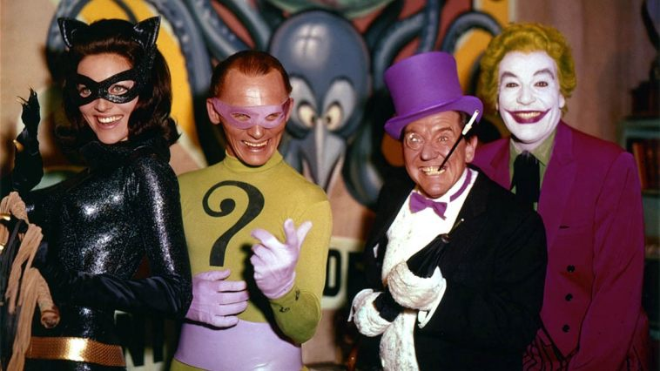

First, let’s look at the very first commercially available superhero movie, Batman the Movie. Batman the Movie was based off of the popular TV series in the 1960s and was released in 1966. The movie starred Adam West as Batman and Burt Ward as Robin. The dynamic duo had a successful movie, but nowadays is laughed on due to cheesy action and dialogue.

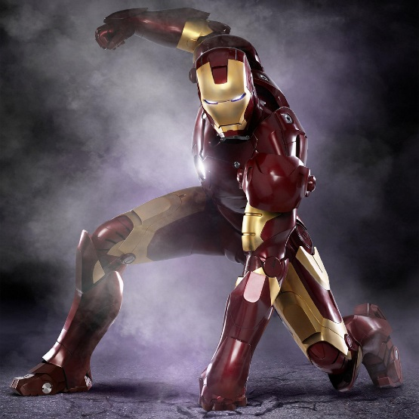

Batman 1966 may have been the first commercially published movie, but what about cinematic universes? Iron Man was made in 2008 and was the first in the Marvel Cinematic Universe. At the time this was unheard of, so the idea of a collection of movies connected through characters and plots was exciting. This universe became split into “phases”.

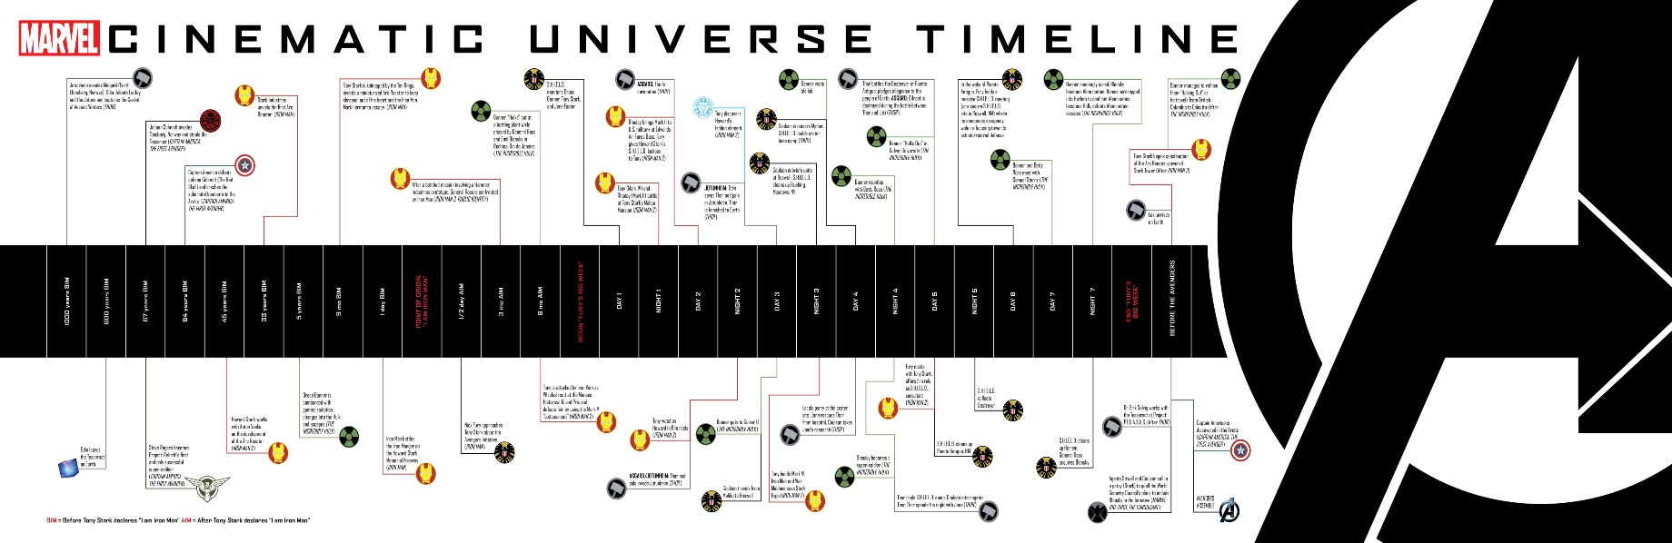
The phases of the MCU (Marvel Cinematic Universe) are events that lead up to the finale, which is always an Avengers movie. At the moment, Marvel Studios are developing the finale for phase three, with no reports on more phases. The movies and TV series are interlocked to each other creating a timeline of events leading up to the Avengers spectacle. At the moment the final boss had been confirmed with the Avengers, as Thanos.

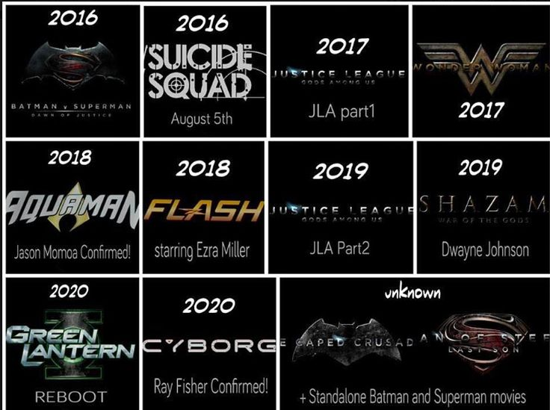

The DC has had the same idea recently. Referred to as the DCEU (Detective Comics Entertainment Universe) which officially started in 2013 with Man of Steel, but has been argued to have started with Arrow in 2012. Although it doesn’t have as much popularity as Marvel, DC aims to deliver a cinematic universe which will have a Justice League finale. The big boss of the DCEU has also been confirmed as Darkseid.

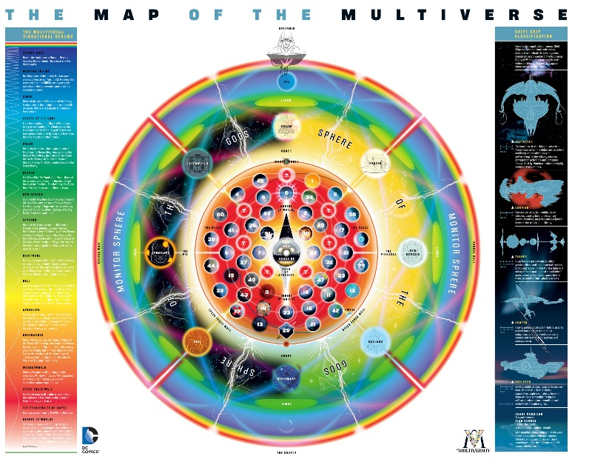

Finally, there is a possibility of a never ending stream of superhero movies. This can be done through multiverses, which have been confirmed in the DCEU and the X Men universe. Multiverses are a big part of comics; basically multiverses are different universes that can be used to reboot or use heroes without ruining a timeline. The X Men did this in Days of Future Past, which started younger X Men films, but still raises questions as to which timeline Logan is set in. The DCEU did this in TV crossovers revealing that the heroes in the TV series are a different multiverse to the movie heroes.

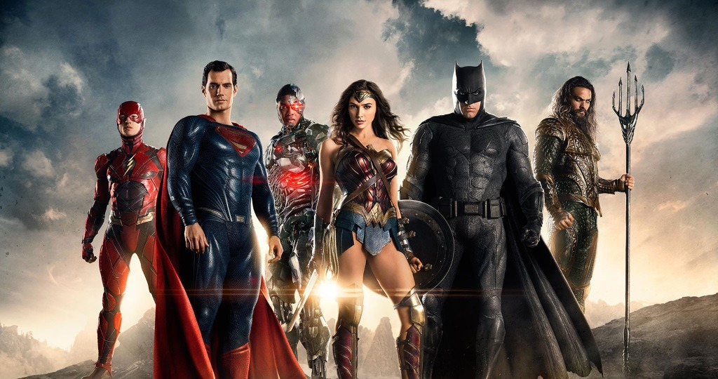

Therefore, in the future there could be an end to superhero movies, but as imaginations grow and fanbases continue to grow, there will be a long and entertaining line of superhero movies. And who knows, maybe old and new movies can cross over due to the multiverse, which provides unlimitless content for directors to create and rebuild.

