Storytelling Week: Creative Writing Competition
Write a story no longer than 500 words. This story must include the location, person and object pictured below. Get creative, why is the person at the location? Why do they have that object?
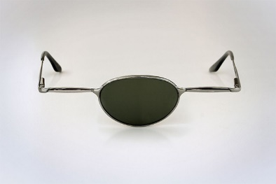
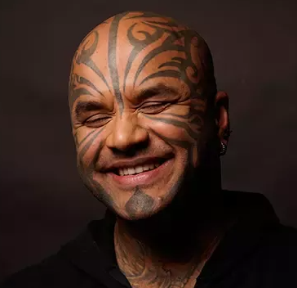
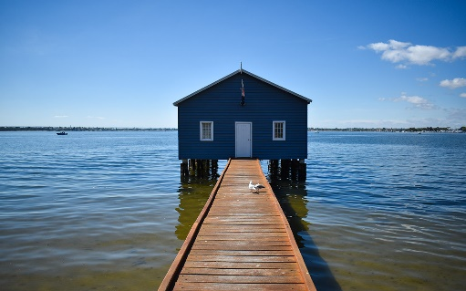
Story Plan
Genre:
Is your story a romance, thriller, fantasy, sci-fi, horror, funny or historical?
Ending:
Make sure you end your story well and it doesn’t end abruptly. Plan your ending before you start writing.
Tension:
A good story always includes tension – make sure you add an event which builds suspense or grabs the reader’s attention.
Object:
Why is their only one lense?
Who does the object belong to?
Why is this object in your story?
Character:
Who are they?
Why are they in your story?

Location:
Where is the location?
Why is the character there?
Who lives there?
Object: A pair of one eyed glasses.
Character: A tattooed man
Location: A house in the middle of a lake.
Location: A run down castle

