Home Learning: Planning for Success
Top Tips for Helping with Home Learning
- Help your child to plan and stick to a weekly home learning routine.
- Agree with the family where your child does their home learning, and try to keep it free from distraction.
If you are having trouble logging in to MCAS, and are unable to retrieve your log-in details using the ‘Forgotten Login Details?’ link on the homepage, please contact the below email address:
mcas@toothillschool.co.uk
- Check what home learning has been set and the instructions given for assignments on MCAS.
- Have a go! It’s really important that your child attempts the home learning. It is ok to make mistakes… that is how we learn!
- Ensure home learning is completed and put in a homework folder or in exercise books ready to hand in.

Home Learning on MCAS – Parents Guide
After logging in to MCAS (link below) Home Learning can be selected from the right-hand tool-bar:
https://www.mychildatschool.com/MCAS/MCSParentLogin
Step 2: Clicking on Home Learning will bring you to the below page, where you will be able to see all Home Learning exercises given to your child in their own rows.

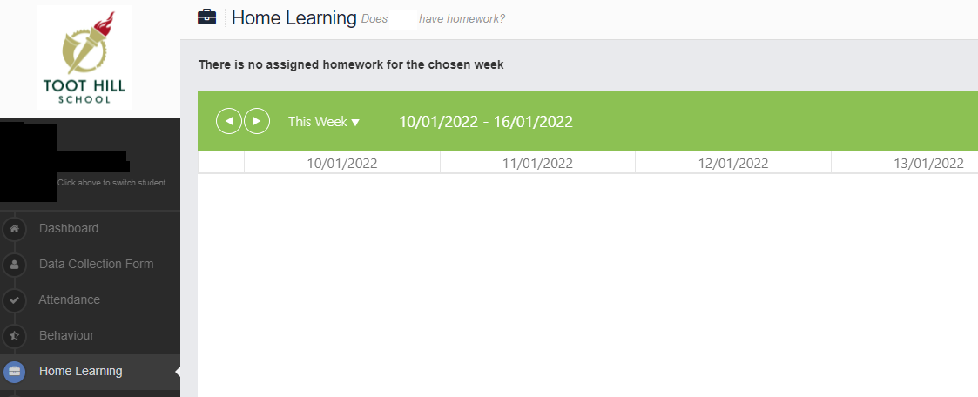
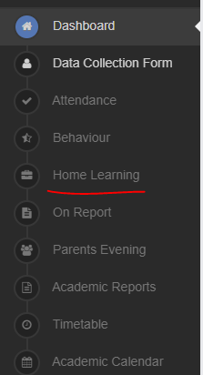
Step 1:
Step 3: Clicking on a Home Learning piece will bring up more details, such as the Home Learning title and description, the due date and any resources such as links to websites or attached documents.

Accessing Home Learning on the Student Portal – Students Guide
To login to the student Portal use the following link: https://www.bromcomvle.com/
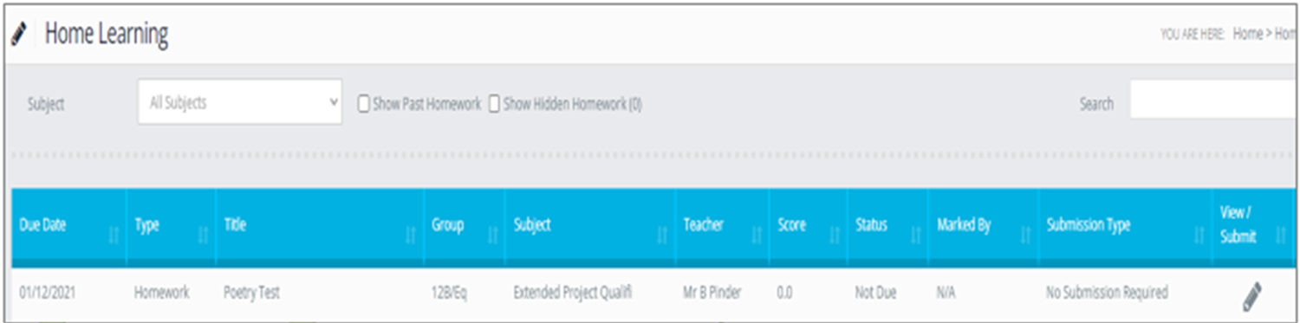
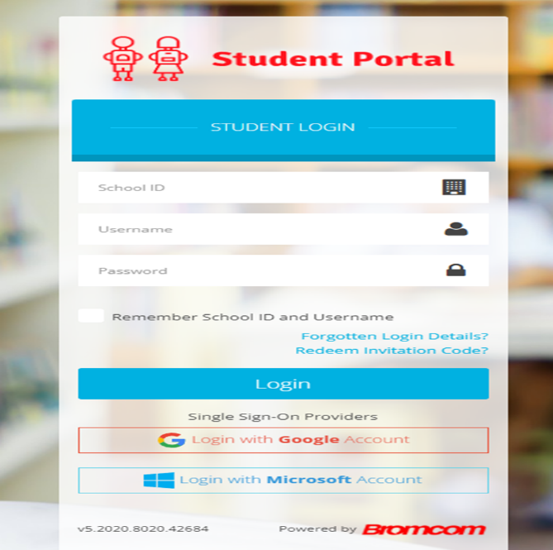
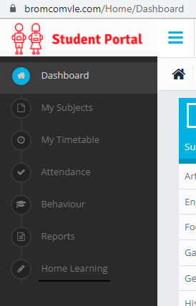
Teacher
Click to view instructions
Subject
Title
Date
due
Step 3: You will be able to see, the Subject, instructions, resources and due date as shown below. Click on the PENCIL symbol to view.

Step 2: When logged in, home learning can be found in the sidebar on the left.

Step 1: Make sure to click “Login with Microsoft Account”

