2016: A Year of Revolution or of Degeneration?

2016 has earned a reputation of being the worst year in a decade, but has it really all been that bad, or have we been focusing on the negatives and not the positives of 2016?
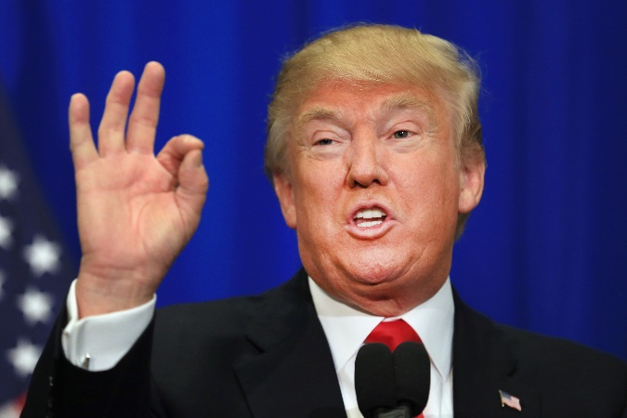

I want to get the biggest one out of the way: Donald Trump. You’ve probably seen his face and heard his name so many times and even more coverage will come in his presidency. It was a surprising win in his election which many have feared and yet many have hoped. It’s been described as a tragedy for America and the world from fear of a nuclear war. But I have to say, it’s mainly speculation. Do not get me wrong, I don’t like him being president, but if you carry on saying we are doomed without giving him a sliver of a chance to be president just seems drastic. I mean there were better options, but at the end of the day, Trump is president. America have chosen him for a reason, so respect that decision and see what happens.

Another very big development was Brexit. Britain was given a very rare opportunity to leave the European Union; the votes showed that the big majority of Britain wanted to leave. This means that we now are an independent country and don’t give any resources to the European Union. On the other hand, the European Union now don’t give us any resources from other European nations and no VIP access to other European nations. This all went into account as some celebrities were saying yes some no. But in reality no one really knew what was going to happen; it had never been done before. Because of this, people wanted to do another vote because they had changed their mind. Just like with Trump, people had second thoughts on their vote. I think that 2016 has been purely a year of very big elections and votes that people have taken for granted, saying that they had second thoughts and now that reality has hit them it all becomes so much more serious.
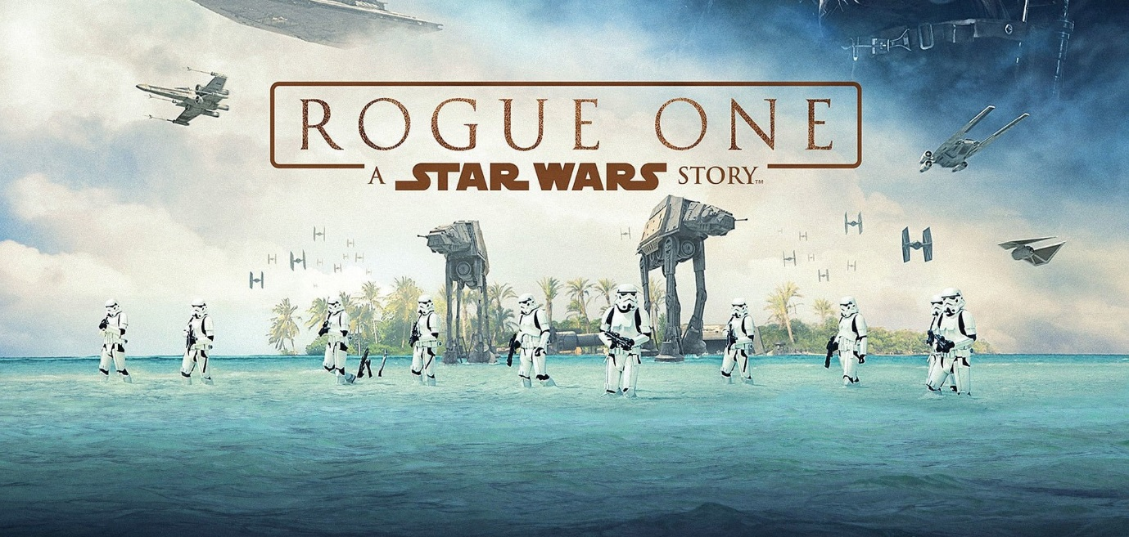
In movies this year, there were mind blowing epics but some unanticipated flops. Films like Rogue One, Fantastic Beasts, Deadpool, Finding Dory, The Revenant, A Monster Calls and more were all extremely successful in the box office. But flops like Batman V Superman, Gods of Egypt, Suicide Squad, Warcraft, Spectre and more have not lived up to audience expectations and have therefore done very bad in the box office and with critics. So in the film industry, 2016 has a very equal mix of good and bad films, but overall has brought some exciting things for the future like the now extended Harry Potter universe in cinema or the still expanding Star Wars universe and even a promising looking DC cinematic universe. So 2016 has been a year of setting a base layer for exciting future cinematic instalments.
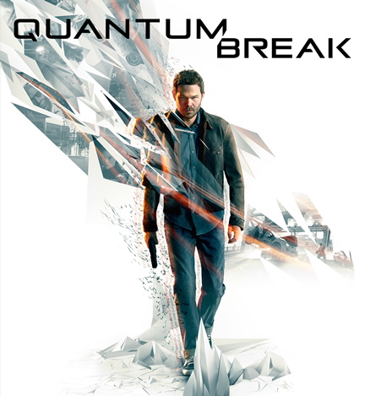

Gaming has brought exciting revolutionary content like Quantum Break, a mix between a game and TV series. As well as very creative and inventive. For example, first person shooters had 2 unique games. Overwatch was a new style of the game’s category with a colourful tone unlike others before it. And Battlefield 1, a World War inspired gameplay that brought a different perspective to war. And Nintendo has been surprising fans with the reveal of Nintendo Switch, a new console coming next year and the new app Mario Run for apple users. As well as, the very popular new Pokémon app and game. Pokémon GO was an app for devices which became one of the most installed apps ever. It’s ideal was to find virtual Pokémon in the real world. Pokémon Sun and Pokémon Moon were also very well received with the new alola forms and Z moves.
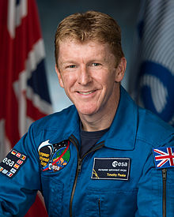

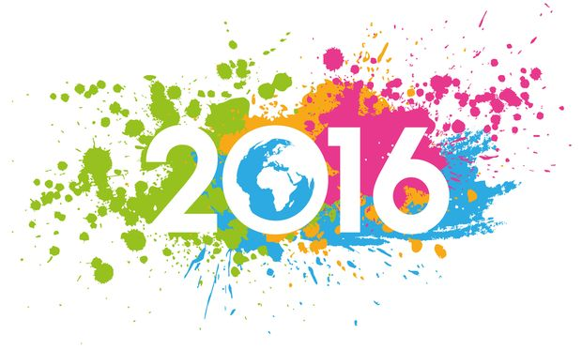
In general news, the Syrian war and terrorist attacks have been more than terrifying and as these attacks ensue people are feeling less and less safe. Also, very popular celebrities like David Bowie, Prince, George Michael, Carrie Fisher, Alan Rickman and more have died this year. Many of them have inspired a generation and to see them pass away brings sorrow to fans and people alike, whose lives were changed because of them. But, as bad as those stories were there was good news. Take for instance Tim Peake, the first British astronaut in space. Or in the Rio 2016 Olympics, Britain won 26 gold medals which put Britain second at the Olympics. So as much as focusing on the horrible news continues to become habit, and as the news keeps producing depressing stories, there is always good news.

As a whole I think 2016 has had its ups and its downs, but in general it has been a year of development. Now, hopefully, people will learn to use their votes wisely, and respect that responsibility as some big mistakes were made in some big areas. Britain though as a whole has done some history changing events and achievements that have resulted in a better Britain. We have lost beloved celebrities, and have seen the worst of crimes, but in the end we learn from mistakes and overtake fears to become stronger as a person and a nation.

