**Theory Revision Sheet: Grade 1**

1.

Note and rest names and lengths: rhythm notation

|  |  |  |  |  |
| --- | --- | --- | --- | --- |
| Name | Note | Rest | Number of beats | ‘Insect’ /  mnemonic |
| Semibreve | http://www.musicchakra.com/opus/lesson-plans/media/semibreve.jpg | semibreve rest | 4 | Bee Cartoon Stock Image |
| Minim | http://www.musical-clipart.com/clipartcontent/thumbs/fc11.jpg | semibreve rest | 2 | http://www.schools.pinellas.k12.fl.us/gallery/cartoon/Cartoon_Apple_with_worm.gif |
| Crotchet | http://img.ultimate-guitar.com/_img/lessons/Babysteps/cort1.jpg | crotchet-rest | 1 |  |
| Quaver | http://www.musicchakra.com/opus/lesson-plans/media/quaver.jpgDescription: http://easymusictheory.weebly.com/uploads/1/1/5/7/11577149/4065699.jpg | quaver-rest | ½ each |  |
| Semiquaver | http://oald8.oxfordlearnersdictionaries.com/media/oald8/thumb/s/sem/semiq/semiquaver.jpghttp://www.ambrosepianotabs.com/userfiles/image/Semiquavers.jpgDescription: http://www.ambrosepianotabs.com/userfiles/image/Semiquavers.jpgDescription: http://www.ambrosepianotabs.com/userfiles/image/Semiquavers.jpgDescription: http://www.ambrosepianotabs.com/userfiles/image/Semiquavers.jpg | semiquaver-rest | ¼ each | 1-10%20Top%20hat%20Caterpillar%20%C2%A3247_50 |

Bar lines and time signatures

Time signature: this could also be: 3 2 The bar lines would then go every 3 beats or every 2 beats.

4 4.

OR

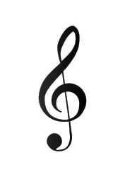

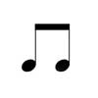

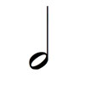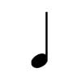

4

4

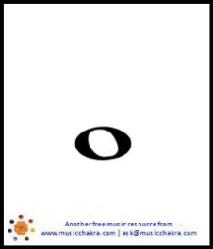

1 + 1 + 1 + 1 2 + 2 ½ + ½ + 1 + 2 4

= 4 = 4 = 4

Double bar line

Means ‘the end’.

Bar lines

Letter names of notes: pitch notation

2.



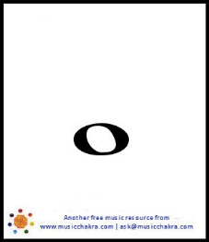





Elephants Go Bald During February F A C E



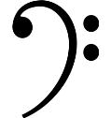



Ghost Busters Don’t Frighten Anyone All Cows Eat Grass

**Theory Revision Sheet: Grade 2**



A sharp ( ) makes a notes a semitone higher.

You should play the black note to the right of the note.

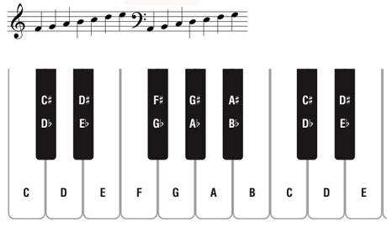

D#

C#



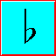



C C# B B



 A sharp means that you should play the black note to the right of the note. The sharp makes the note a semitone higher. A semitone is the smallest distance between two notes on a keyboard.

 A sharp means that you should play the black note to the right of the note. The sharp makes the note a semitone higher. A semitone is the smallest distance between two notes on a keyboard.

 A sharp means that you should play the black note to the right of the note. The sharp makes the note a semitone higher. A semitone is the smallest distance between two notes on a keyboard.

A flat ( ) makes a notes a semitone lower.

You should play the black note to the left of the note.

**Theory Revision Sheet: Grade 2**

3.

Dotted notes and rests

A dot after a note or rest adds on half the value of the note or rest.

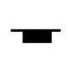

+ =

+ = 

4 + 2 = 6

4 + 2 = 6

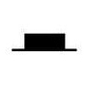



2 + 1 = 3

+ =

+ =

2 + 1 = 3



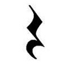

+ = 

+ =

1 + ½ = 1 ½

1 + ½ = 1 ½

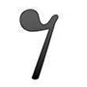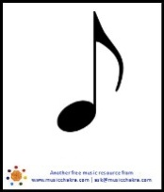

+ =

+ =



½ + ¼ = ¾

½ + ¼ = ¾

Ties

A tie is a curved line that joins two notes that are the same pitch.

You only play the first note and hold it for the value of both notes.



4

4

4

2

**1½ beats 3 beats**

Intervals

4.

An interval is the distance between two notes.

Intervals are measured using numbers e.g. 2nd, 3rd, 4th etc.



1

4

3

2

1

5

2

3

4

G to C

makes an

interval

of a 4th.

C

G

2

F

1

E to F

makes an

interval

of a 2nd.

A to E makes an interval of a 5th.

E

A

E

Then count up through the lines and spaces until you reach the top note.

To work out the interval between two notes, count the bottom note as ‘1’ …

Tones and semitones

A semitone is the smallest distance between 2 notes.

E - F

D – D#

C - C#



A tone is two semitones.

F# - G#



E – F#

C - D