7TH SPANISH

Home Learning
Theme 2 – Mi Colegio

Name: ______________________________________________
Class: _____________
Teacher: ____________________________________________

Overview:
Week | HOME LEARNING | Done?
1 | Vocab learning:  Activity: Reading and translation
2 | Vocab learning:  Activity: Reading and writing
3 | Vocab learning:  Activity: Translation and roleplay
4 | Vocab learning:  Activity: Translation and reading
5 | Vocab learning:  Activity: Sorting and translation
6 | Vocab learning:  Activity: Sorting and translation
7 | Vocab learning:  Activity: True/False and translation
Know your basics!
Revise these if/when you need to
Numbers
cero | 0 | dieciséis |  | 16
uno | 1 | diecisiete |  | 17
dos | 2 | dieciocho |  | 18
tres | 3 | diecinueve |  | 19
cuatro | 4 | veinte |  | 20
cinco | 5 | veintiuno |  | 21
seis | 6 | veintidós |  | 22
siete | 7 | veintitrés |  | 23
ocho | 8 | veinticuatro |  | 24
nueve | 9 | veinticinco |  | 25
diez | 10 | veintiséis |  | 26
once | 11 | veintisiete |  | 27
doce | 12 | veintiocho |  | 28
trece | 13 | veintinueve |  | 29
catorce | 14 | treinta |  | 30
quince | 15 | treinta y uno |  | 31
cuarenta |  |  | 40
cincuenta |  |  | 50
sesenta |  |  | 60
setenta |  |  | 70
ochenta |  |  | 80
noventa |  |  | 90
cien |  |  | 100

Days
lunes | Monday
martes | Tuesday
miércoles | Wednesday
jueves | Thursday
viernes | Friday
sábado | Saturday
domingo | Sunday

Months
enero | January
febrero | February
marzo | March
abril | April
mayo | May
junio | June
julio | July
agosto | August
septiembre | September
octubre | October
noviembre | November
diciembre | December

Colours
Rojo | Red
Naranja | Orange
Amarillo | Yellow
Verde | Green
Azúl | Blue
Violeta | Purple
Rosa | Pink
Negro | Black
Blanco | White
Marrón | Brown
Pelirrojo | Red (hair)
Gris | Grey

Sentence builder 1
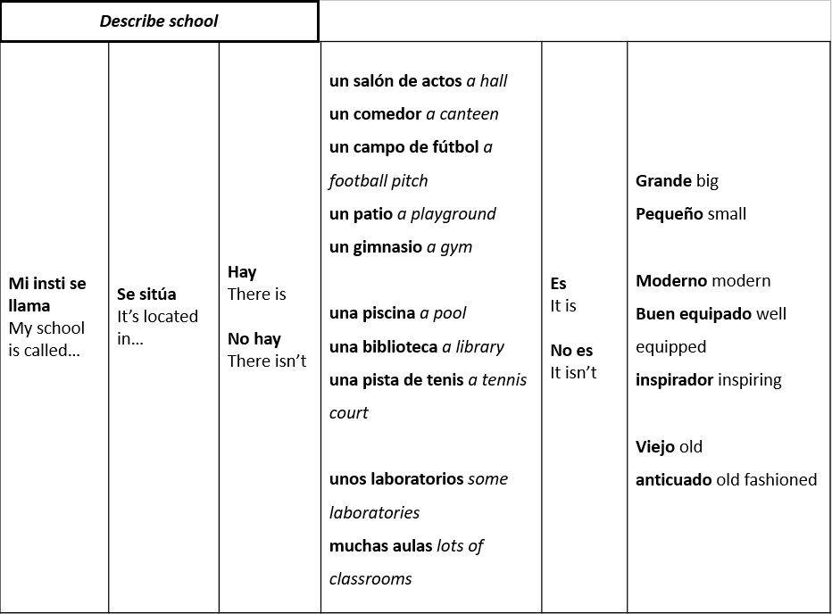

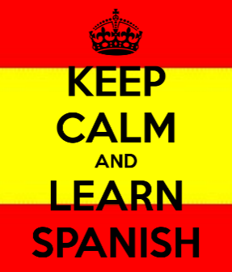
Week 1
Vocab learning
- You can use Quizlet to help you learn and practise your words.
- Make sure you know what each Spanish phrase / word means in English.
- Make sure you can translate each English phrase / word into Spanish.

Reading
Mi instituto es pequeño y antiguo. Hay un bonito patio y un comedor muy cómodo, pero no hay biblioteca. Hay unas aulas y un laboratorio. No hay gimnasio – practicamos deporte en el patio.

- Key words
What do all the bold words have in common? ………………………………………………………………
What do all the words in italics have in common? ………………………………………………………

- Answer the questions in English
How do they describe their school? (2) ……………….………………………………………………………
What facilities are there in their school? (4) ………………………………………………………………
…………………………………………………………………….……………………………………………………………………………
What facilities do they not have? (2) ……………….………………………………………………………

- Translate the text into English
…………………………………………………………………….……………………………………………………………………………
…………………………………………………………………….……………………………………………………………………………
…………………………………………………………………….……………………………………………………………………………
…………………………………………………………………….……………………………………………………………………………

- Complete the sentences to describe Toot Hill or another school of your choice.
- Mi insiti se llama ………………………………………………………………………………………………………
- Se siitúa en ………………………………………………………………………………………………………
- Hay ………………………………………………………………………………………………………
- No hay ………………………………………………………………………………………………………
- Me gusta/no me gusta mi insti porque es ……………………………………………………………………………………………………… y no es ……………………………………………………………………………………………………….
- Translate your sentences into English.
- ………………………………………………………………………………………………………………………………………
- ………………………………………………………………………………………………………………………………………
- ………………………………………………………………………………………………………………………………………
- ………………………………………………………………………………………………………………………………………
- ………………………………………………………………………………………………………………………………………………………………………………………………………………

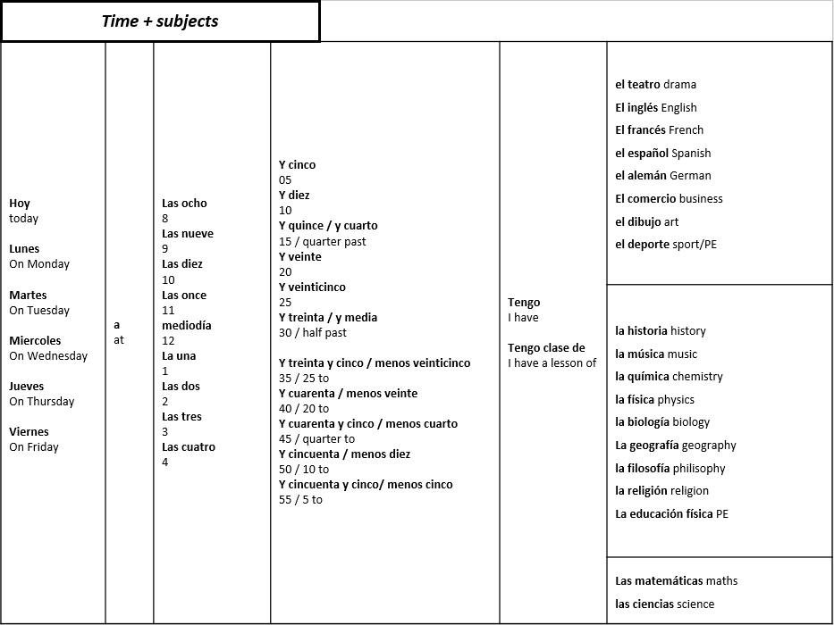
Sentence builder 2
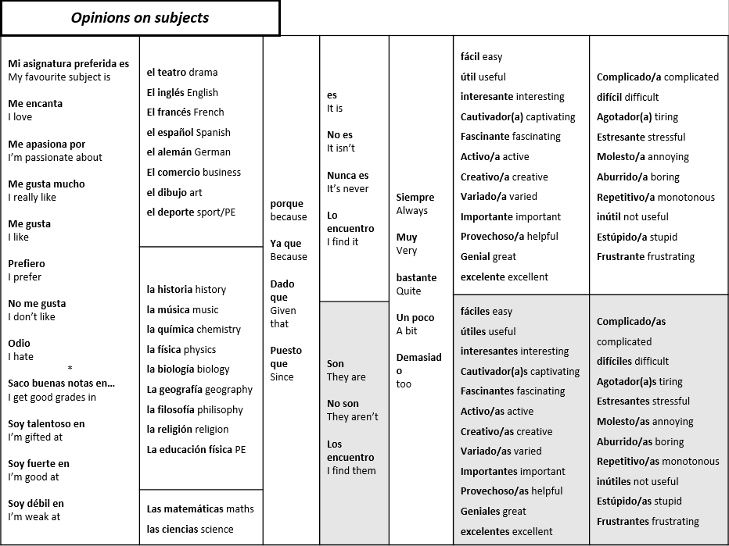
Sentence builder 3
Week 2
Vocab learning
- You can use Quizlet to help you learn and practise your words.
- Make sure you know what each Spanish phrase / word means in English.
- Make sure you can translate each English phrase / word into Spanish.
Translation
¡Hola!
Me llamo Felipe y vivo en Madrid. Voy al instituto de la Reina Isabel. Tengo clases desde las nueve de la mañana hasta las cinco de la tarde. Tenemos un recreo de quince minutos a las once. La hora de comer es a la una. Normalmente como en casa con mi familia. Tenemos clase otra vez a las tres. El miércoles tenemos deporte.

- Lee el correo electrónico.
What time does Felipe start school? ……………….………………………………………………………
What time does he finish? ……………….………………………………………………………
How long is his break? ……………….………………………………………………………
What time is lunch? ……………….………………………………………………………
Where does he eat lunch? ……………….………………………………………………………
When do classes start again in the afternoon? ……………….……………………………………………
What does he do on Wednesday afternoon at school? ……………….………………………………

- ¿Cómo se dice…? (Find the Spanish for these phrases in the text)
From 9am in the morning ……………………………….. on Wednesday ………………………………..
Til 5pm in the afternoon ……………………………….. with ………………………………..
15 minutes long ……………………………….. but ………………………………..
Normally ……………………………….. at home ………………………………..
- Fill in the gaps to complete the paragraph with the words below
Estudio inglés el lunes, el martes y …………………………….. es fantástico. Me encanta el inglés, es fácil y……………………….. No estudio …………………………..porque no me gusta nada. El teatro es mi asignatura preferida y ………………………………. es muy …………………………..y simpática.
Inteligente / divertido / geografía / el miércoles / la profesora
- Translate the following into English
- Me gusta el inglés porque es interesante.
- No me gusta la geografía porque es aburrido.
- Odio las ciencias porque son difíciles.
- Me encanta la educación física porque soy deportista.
- Me gusta el español porque es útil.
1, ………………………………………………………………………………………
2, ………………………………………………………………………………………
3, ………………………………………………………………………………………
4, ………………………………………………………………………………………
5, ………………………………………………………………………………………
- Translate these phrases into Spanish.
I don’t like English because it is difficult.
…………………………………………………………………………………………………………………………………………………
I like maths because it is easy.
…………………………………………………………………………………………………………………………………………………
I really like history because it is funny.
…………………………………………………………………………………………………………………………………………………

Sentence builder 4
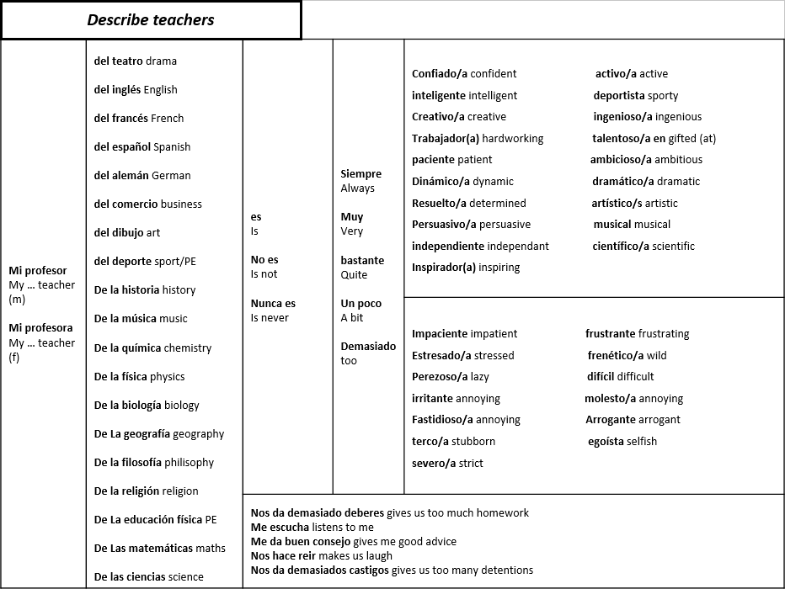

Week 3
Vocab learning
- You can use Quizlet to help you learn and practise your words.
- Make sure you know what each Spanish phrase / word means in English.
- Make sure you can translate each English phrase / word into Spanish.

A. Gap fill : Use the words in the box to complete the paragraph
En mi colegio, mi __________ preferida es el _________ porque el _______ es divertido.
También me gusta la _________ porque lo encuentro ___________ .
Sin embargo, no me ______ la educación física porque no soy ________ y el profesor es _________ .
deportista
geografía
español
profesor
francés
interesante
gusta
tonto
asignatura

B. Translate the completed text into English.
…………………………………………………………………………………………………………………………………………………
…………………………………………………………………………………………………………………………………………………
…………………………………………………………………………………………………………………………………………………
…………………………………………………………………………………………………………………………………………………
…………………………………………………………………………………………………………………………………………………
…………………………………………………………………………………………………………………………………………………
C. Write sentences in Spanish based upon the pictures about the subjects and teachers.
1,
……………………………………………………………………………………………………

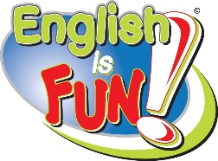
……………………………………………………………………………………………………
2,

……………………………………………………………………………………………………
3,

4,
……………………………………………………………………………………………………

5,
……………………………………………………………………………………………………

Sentence builder 5
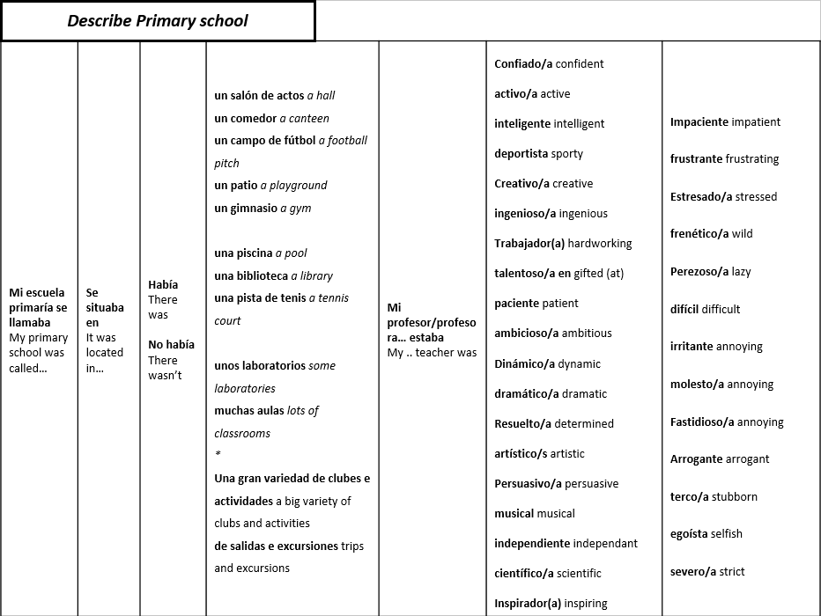

Week 4
Vocab learning
- You can use Quizlet to help you learn and practise your words.
- Make sure you know what each Spanish phrase / word means in English.
- Make sure you can translate each English phrase / word into Spanish.

1. Past or present ?
- Me gustaban las matemáticas porque estaban fáciles.
- Mi asignatura preferida es la historia porque es fascinante.
- Mi profesor estaba simpático y divertido.
- Mi profesor de inglés es demasiado estricto.
- Mi asignatura preferida estaba la educación física porque estaba muy deportista.
- No me gusta el deporte porque es difícil.
2, Translate the sentences from part 1 into English
1 ………………………………………………………………………….
2 ………………………………………………………………………….
3 ………………………………………………………………………….
4 ………………………………………………………………………….
5 ………………………………………………………………………….
6 ………………………………………………………………………….
3. Read the text and answer the questions in English.
Mi escuela primaria se llamaba ‘Colegio Miraflores’ y se sitúa en Zaragoza en el noreste de España. Había un comedor pequeño y un patio, pero no había laboratorios. Me encantaba el teatro y el dibujo porque mi profesor era creativo y paciente. No me gustaba el deporte y mi profesora era molesta e impaciente.
- What was their primary school called ?..................................................
- Where was it located in Spain? ..................................................
- What facilities were there? ..................................................
…………………………………………………………………………………………………………….
- What wasn’t there? ..................................................
…………………………………………………………………………………………………………….
- What subjects did they like and why? ..................................................
…………………………………………………………………………………………………………….
- What subject did they not like and why? ..............................................
…………………………………………………………………………………………………………….
4. Answer the following questions IN SPANISH
¿Qué tu gustaba cuando era en la escuela primaria?
………………………………………………………………………….
………………………………………………………………………….

¿Qué no te gustaba?
………………………………………………………………………….
………………………………………………………………………….

Sentence builder 6
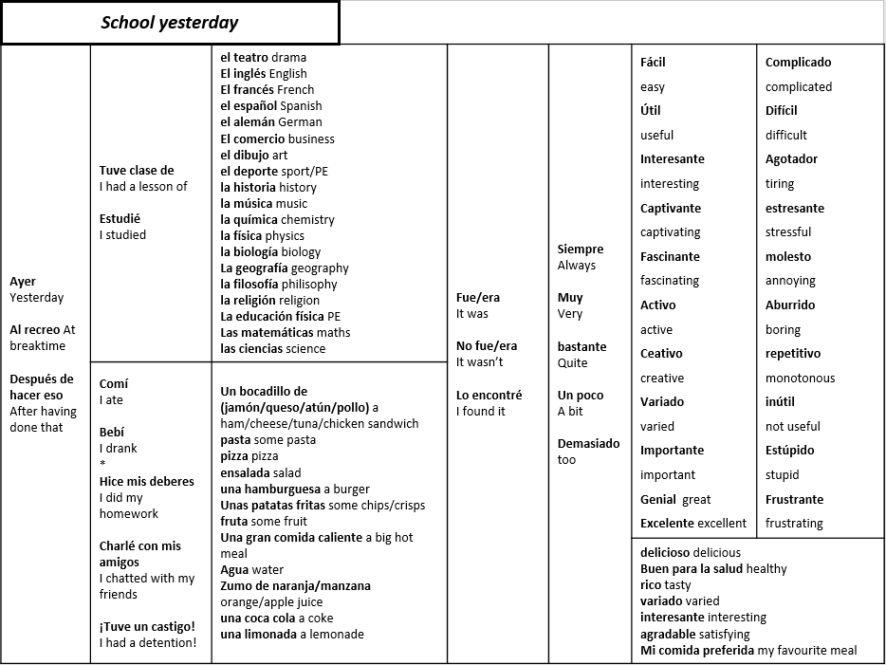

Week 5
Vocab learning
- You can use Quizlet to help you learn and practise your words.
- Make sure you know what each Spanish phrase / word means in English.
- Make sure you can translate each English phrase / word into Spanish.

1. Highlight and translate the verbs in the past tense.
Estudié | Juego | Comí
Como | Hice | Estudio
Jugué | Hago | Fue
 | Es

El fin de semana pasado
El domingo pasado
ayer
Hace tres días
La semana pasada
- Match up the past tense time phrases
Yesterday
Last week
Last weekend
Last Sunday
- days ago

- Translate the passage below into English.
Ayer en mi colegio estudié el español que es* mi asignatura preferida y fue genial. También hice el inglés y las matemáticas, fue un poco aburrido. En el recreo** jugué al fútbol con mis amigos y comí una manzana.
*which is
**at breaktime

…………………………………………………………………………………………………………
…………………………………………………………………………………………………………
…………………………………………………………………………………………………………
…………………………………………………………………………………………………………
…………………………………………………………………………………………………………
4. Translate the sentences below into Spanish (use the sentences in part 2 to help you.)
a. Yesterday at school, I studied geography, which is my favourite subject and it was fun.
…………………………………………………………………………………………………………
…………………………………………………………………………………………………………
b. Also I did history and drama but it was really difficult.
…………………………………………………………………………………………………………
…………………………………………………………………………………………………………
c. At breaktime I played tennis with my friends and I ate a banana.
…………………………………………………………………………………………………………
…………………………………………………………………………………………………………
Bonus! Write your own description of a recent school day.
…………………………………………………………………………………………………………
…………………………………………………………………………………………………………
…………………………………………………………………………………………………………
…………………………………………………………………………………………………………
…………………………………………………………………………………………………………

Week 6
Vocab learning
- You can use Quizlet to help you learn and practise your words.
- Make sure you know what each Spanish phrase / word means in English.
- Make sure you can translate each English phrase / word into Spanish.

  - Sort the verbs into the preterite and imperfect tense.
Which would you use to talk about your day yesterday (preterite) and which would you use to talk about your primary school (imperfect)?
Había | Estudié | Me gustaba
Comí | Era | Se sitúa
Charlé | Mi insti se llamaba | Hice
Odiaba | Tuve | No había

  - Translate the sentences into English.
a. Mi escuela primaria se sitúa en Valencia en el sur de España.
…………………………………………………………………………………………………………
…………………………………………………………………………………………………………
b. Ayer, estudié la geografía que es mi asignatura preferida.
…………………………………………………………………………………………………………
…………………………………………………………………………………………………………
c. Me encantaba el inglés y las matemáticas y mi profesor era inteligente y trabajador.
…………………………………………………………………………………………………………
…………………………………………………………………………………………………………
d. Al recreo charlé con mis amigos y comí una manzana.
…………………………………………………………………………………………………………
…………………………………………………………………………………………………………

  - Translate the sentences into Spanish. Check your verbs carefully, should you use the preterite or the imperfect?
a. Yesterday at school, I studied music, which is my favourite subject and it was great.
…………………………………………………………………………………………………………
…………………………………………………………………………………………………………
b. My primary school was small and old fashioned.
…………………………………………………………………………………………………………
…………………………………………………………………………………………………………
c. Also I did science and art but it was really rubbish.
…………………………………………………………………………………………………………
…………………………………………………………………………………………………………
d. At breaktime I played football with my friends and I ate a cheese sandwich.
…………………………………………………………………………………………………………
…………………………………………………………………………………………………………
e. At primary school I loved my teacher because she was kind and creative.
…………………………………………………………………………………………………………
…………………………………………………………………………………………………………

Sentence builder 7
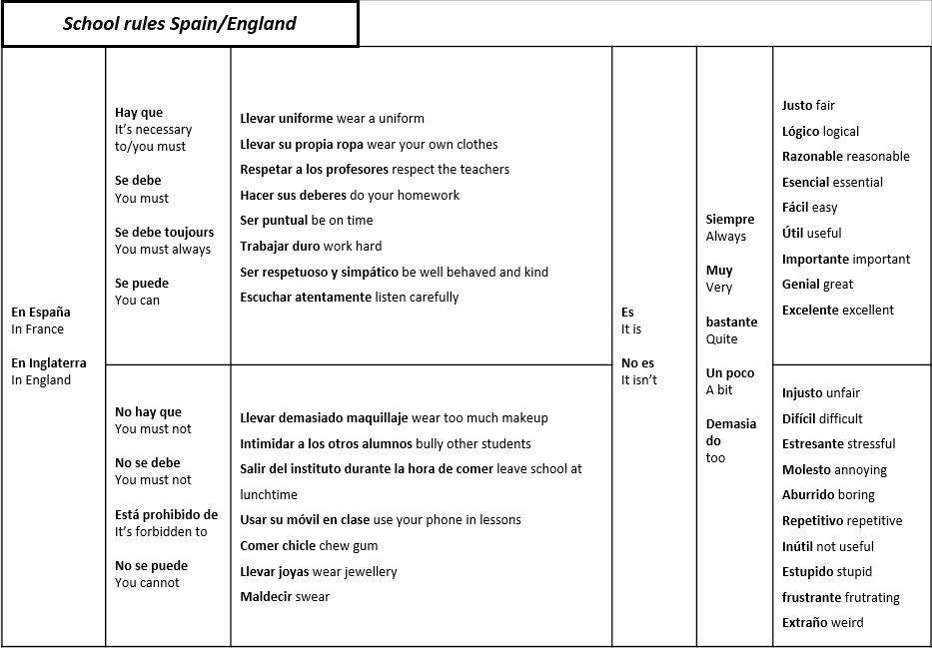
Sentence builder 8
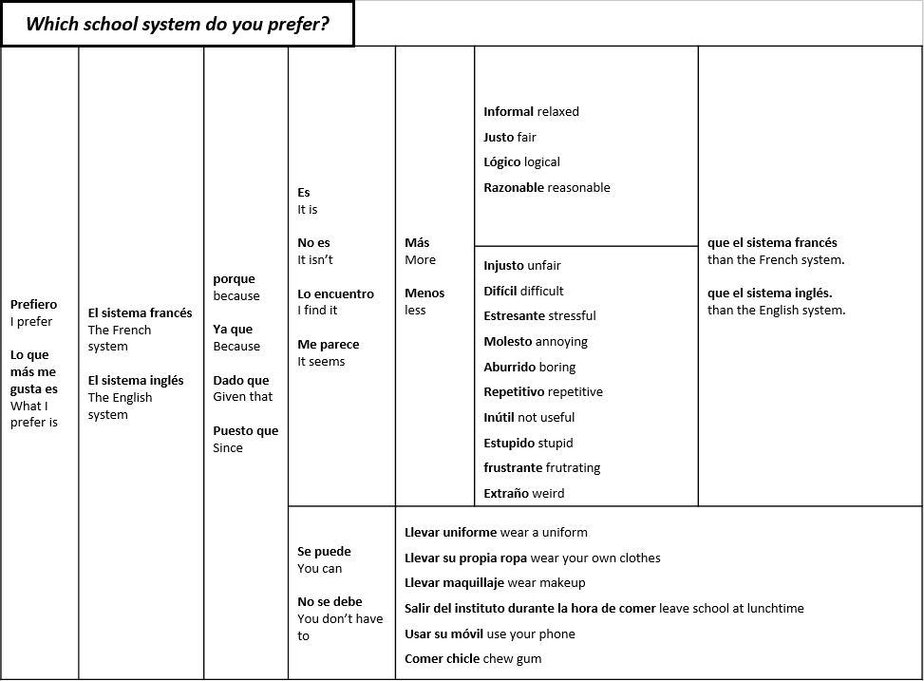
Week 7
Vocab learning
- You can use Quizlet to help you learn and practise your words.
- Make sure you know what each Spanish phrase / word means in English.
- Make sure you can translate each English phrase / word into Spanish.

1. ¿Verdadero o Falso ? (True or False)
1, En España, empiezan el colegio a las diez de la mañana. ____________
2, Estudian una variedad más grande de asignaturas. _____________
3, No llevan un uniforme escolar. _____________
4, Terminan las clases a las dos de la tarde. ___________
5, Tienen dos horas para el almuerzo. ______________
6, Tienen las vacaciones de verano más largas. ____________

BONUS : CORRECT THE FALSE SENTENCES
………………………………………………………………………….
………………………………………………………………………….
………………………………………………………………………….
………………………………………………………………………….
………………………………………………………………………….
2. Verbs – select the correct spelling to complete the sentences
1, En Inglaterra, [hago/hace/hicimos] las ciencias diferentes.
2, [Estudiamos/Estudian/Estudie] también el inglés y el español.
3, [Tenemos/Tengo/Tienen] seis semanas de vacaciones en verano.
4, [Juego/jugamos/juegan] al cricket en la educación física.
5, pero en España, [prefiero/prefieres/prefieren] el tenis o el fútbol.
6, Las clases [empieza/termina/empiezan] a las ocho y media.
7, y [terminan/empieza/termine] a las quince y media.

3. Translate the sentences into FRENCH (HINT: Use the sentences above for help).
1. We study English and Maths.
2. We also do PE and science.
3. We have 6 weeks for holidays in summer
4. We play tennis in PE
5. but in Spain they play football or handball
6. Lessons start at 8.45
7. and finish at 3.10
1 ………………………………………………………………………….
2 ………………………………………………………………………….
3 ………………………………………………………………………….
4 ………………………………………………………………………….
5 ………………………………………………………………………….
6 ………………………………………………………………………….
7 ………………………………………………………………………….

