Geography – Rivers, Sustainable urban living, Newly Emerging Economies, Economic futures in the UK
Revision is not an optional task. You must complete all the tasks in the booklet. Failure to complete the tasks will result in you having to come back and complete them at lunchtime or afterschool.
If you are unsure or stuck with any part of the work you must speak to your teacher about this. Your teacher will then be able to help you.
Booster sessions before exam:
Your teacher may organise a booster session for you or your class. Ask them – this may be at lunchtime or after school.
Your exam weeks are from 3rd May to 13th May.
Work to be completed:
Date – week beginning | What needs to be completed? | Deadline for completion
11th April | Revision A3 mind map for Rivers
18th April | Flash cards for – Sustainable urban living and Newly Emerging Economies
27th April | Revision A3 mind map for Economic futures in the UK
3rd May till your exam | Read back through your notes | N/A

In this pack is a variety of revision resources:
- Rivers
- Sustainable urban living
- Newly Emerging Economies
- Economic futures in the UK

Sustainable urban living
What is urbanisation?
- Urbanisation is the increase in the proportion (%) of people living in urban areas and a decrease in those living in rural areas
Is urbanisation different in rich and poor countries?
- The simple answer is Yes
  - Most of the population in richer countries already live in urban areas
  - Not many of the population in poorer countries currently live in urban areas
  - Most urbanisation is happening in poor countries and at a fast pace
Urbanisation in richer countries
  - Must urbanisation occurred in 18th and 19th Centuries
    - Industrial and agricultural revolutions
  - Machinery replaced farm labour
  - More jobs created in new factories in urban areas
  - People moved from farms to towns for work
  - Late 20th Century – people left run down inner city areas and moved to the country
  - Redevelopment of these areas encourages the people back in
What is a megacity?
- A megacity is one that has over ten million people
- Why are they growing so quickly?
  - Natural increase – lots of births and fewer deaths due to youthful population
  - Migration – many people moving into the city in search of work
  - Push factors - are disadvantages or problems with an area that cause people to leave - such as few jobs, lack of educational or medical facilities & religious persecution
  - Pull factors - are advantages that attract migrants to a particular destination - They are often the opposite of push factors or could be more specific as in many wishing to come to Britain for their knowledge of the language for example

Part B: What is a sustainable city?
- Definition:
  - A sustainable city is one that is designed with consideration of environmental impact, a commitment to renewable energy and a reduction in waste output
Water conservation:
In Vegas they have tried to conserve (save) water by:
- Building a dam to create Lake Mead to trap water
- Advertising campaigns showing the best times to water the lawns – at night when the water can soak into the ground as opposed to midday when the water would just evaporate off
- Financial incentives to remove turf and plant desert adapted species which require less water
- Recycling water that flows through the drains and feed it directly into Lake Mead
Energy conservation:
In Sweden they have tried to conserve (save) energy by:
- The city uses ethanol and biodiesel which do not give out as much carbon dioxide
- The city has retain most of its natural forest and promotes cycling and walking so there is less energy use when compared to a car journey
- Biomass and biofuels are produced from the forest and then the trees are replanted – 40% of electricity and 80% of heating comes from burning biomass (dead plant material).
- Using wind energy and solar energy to provide electricity
- All buildings have double or triple glazed windows so heat is trapped in the building, keeping them warmer so less heating is needed
Creating green spaces:
In London they have created green spaces by:
- Providing 35,000 acres of public space
- The City of London looks after 11,000 acres of green space in and around London
- Stop development of new buildings on these areas
- Environmental benefit: provides habitats for many different species
- Social benefit: allows people time to relax and gives people access to some outside space when often people do not have gardens in London
Waste disposal:
In Surrey they have tried to improve:
- Increasing recycling rates
- Using Compressed Natural Gas (CNG) Trucks emit 23% less carbon emission and 90#5 less air pollutants – this is the equivalent of removing 475 cars of the road each year
- Separating kitchen and yard waste and collecting organic material separately which can be composted, more is recycled and less goes into landfill sites.

Traffic congestion:
- Traffic congestion is a condition on road networks that occurs as use increases, and is characterized by slower speeds, longer trip times, and increased vehicular queueing.
Problems caused by traffic congestion:
Increased air pollution – greenhouse gas emissions
Poor efficiency of transporting goods leading to longer delivery times for businesses
Delays which may result in late arrival for a job or school
Blocked traffic may interfere with the passage of emergency vehicles
Higher chances of collisions due to tight spacing and constant stopping-and-going
Stressed and frustrated motorists, encouraging road rage and reduced health

Solutions to traffic congestion:
- Park and ride schemes
  - Park and ride schemes such as Colwick racecourse and Phoenix road
  - For park and ride schemes people park their car in a car park outside of the city centre and then catch a bus to the city centre
  - Park and ride schemes means there are less cars in the city centre
- Trams
  - Develop the tram network into areas such as West Bridgford and Sherwood
  - A tram can fit more people in than a car which means there are less cars on the road thus potentially reducing congestion
- Pedestrianisation
  - Pedestrianisation – concreting the roads in the city centre
  - Areas of Nottingham such as Market Square have been pedestrianised, which will exclude cars so therefore reducing traffic congestion
- Cycle lanes
  - Nottinghamshire has 650 miles of cycle lanes and is adding more
  - If you have more cycle lanes which are safe from other vehicles; people may be more willing to travel by bike this reducing the number of cars on the road
- Buses
  - Improving the reliability of Nottingham’s buses which will make them more attractive to drivers so use them more.
  - This means there will be less cars on the road making it easier for cars to more through.
A sustainable city: Curitiba
Curitiba is a capital city of the Parana state in Brazil. Nearly two million people live there. The city has had an urban master plan since the 1968. It is an excellent example of managing urban growth in a sustainable way. The master plan includes social, economic and environmental programmes. It includes:

- Creating and retaining parks and green space beside the rivers. This acts as a floodplain. When the Iguazu River floods, some areas created are used as boating lakes.
- The green spaces being dedicated to different ethnic and immigrant groups.
- Urban growth is restricted to corridors of growth - along key transport routes. Tall buildings are allowed only along bus routes.
- A bus rapid transit system operates. This is cheaper to run than a tube system. Some employers subsidise their employees who use it. 80% of travellers use it.
- The bus rapid transit system uses triple section bendy buses. It carries two million passengers a day. The bus fare is the same wherever you go. No one lives more than 400 metres from a bus stop.
- "Lighthouses of Knowledge". These are free educational and internet centres.
- A green exchange programme. The urban poor bring their waste to neighbourhood centres. They can exchange their waste for bus tickets and food. This has many advantages, for example the urban poor areas are kept clean, despite waste trucks not being able to reach them easily.
- COHAB, the public housing programme, is providing 50,000 homes for the urban poor.
- Exchanging 5kg of waste for 1kg of fresh fruit and vegetables

BedZed
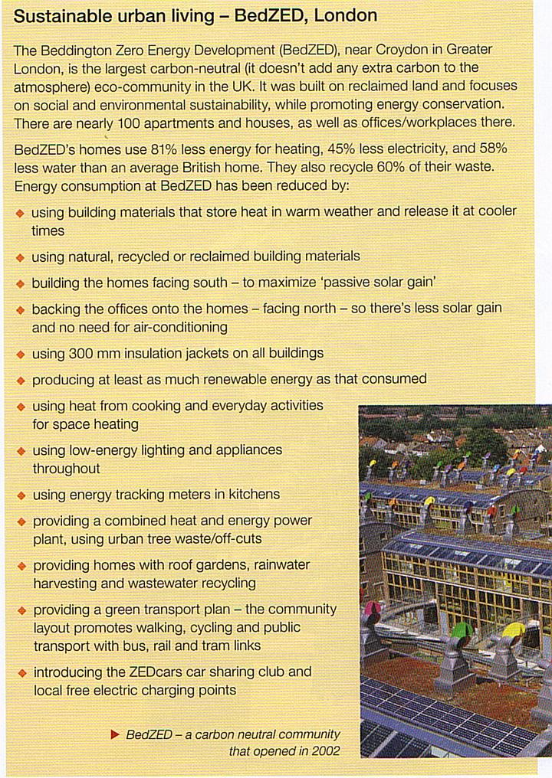

Newly Emerging Economy (Rio, Brazil)
Why is Rio important?
- Where is Rio?
  - Rio is a large coastal city located on the South-East coast of Brazil
- Rio is important nationally because…..
  - Second largest city in Brazil
  - Main tourist destination – Christ the Redeemer and the Carnival
  - Population of approximately 6 million people
  - Second largest city of industrial production as well as its financial and service industries (chemicals, pertroleum, processed foods, pharmaceuticals, textiles, clothing and furniture).
- Rio is important internationally because…
  - Host the 2016 Olympics and Para Olympics
  - Major oil reserves and industrial powerhouse
  - Largest economy in Latin America

Why is Rio growing?
- Rural-to-urban migration – people moving from the countryside to the city
- Natural increase – people having more babies. As more people live in towns and cities there will be an increase in births
Push Factors | Pull Factors
Poor healthcare | Good healthcare
No jobs | Jobs
Poor sanitation | Good sanitation
Drought | Clean water
War | Access to food
No food | No crime
Poor housing | Protection from persecution

What opportunities has urban growth created?
Social opportunities | Economic opportunities
Sick children can get treated. | Easier to get permits for travel and business
Anti-biotics are available in the hospitals for babies | Lots of people in the city to sell goods to
Children can go to school and get qualifications for the future | Consistent electricity supply so machines always run making it easier to make money
Water is cleaner in the city | New industrial areas (Santa Cruz) – this has attracted lots businesses and industry such as sawmills
Satellite TV and good electricity supply | New businesses like sawmills cause new businesses to set up such as paper shop and a machine repair business
Access to good schools and university

What challenges has urban growth created?
Characteristics and problems of squatter settlements
· settlements are unplanned so the houses do not have basic infrastructure such as sanitation, piped water, electricity and road access
· houses are made of any material available nearby - corrugated iron, pieces of board - haphazardly assembled to provide a basic shelter
· houses have a simple layout that may have a living area separate from a sleeping area
· parents and large families inhabit a small shack which is often overcrowded and the squatter settlements are very overcrowded
· there are no toilets, water must be collected from a nearby source - often at a cost - and carried back
· rubbish is not collected and the area quickly degenerates into a place of filth and disease
· the inhabitants tend to create poorly paid jobs where the income is unreliable or they work in the less well-paid jobs part of the formal sector
· quality of life is poor; the housing and environment are largely responsible for this
· the residents have very little money so cannot improve their homes or environments
· crime is a problem, children often do not go to school, the family lives on top of each other, there is no privacy, disease is rife and life is one of trying to survive from one day

How can we improve squatter settlements?
Self-help occurs where local authorities support the residents of the squatter settlements in improving their homes. This involves the improvements outlined above, but it is more organised. There is cooperation between residents to work together and remove rubbish. There is also cooperation from local authority, which offers grants, cheap loans and possibly materials to encourage improvements to take place. Standpipes are likely to be provided for access to water supply and sanitation. Collectively, the residents, with help from the local authority, may begin to build health centres and schools. Legal ownership of the land is granted to encourage improvements to take place, marking an acceptance of the housing.

Site and service schemes are a more formal way of helping squatter settlements residents. Land is identified for the scheme. The infrastructure is laid in advance of settlement, so that water, sanitation and electricity are properly supplied in individually marked plots. People then build their homes using whatever materials they can afford at the time. They can add to and improve the structure if finances allow later.

Economic futures in the UK
Key term | Definition
Primary industry | The collection of raw materials or growing of crops
Secondary industry | The manufacturing of a product from raw materials
Tertiary industry | A service provided usually to sell the product but also education, healthcare and financial services
Quaternary industry | Research and development – robotics, medical research and hi-tech research
Industrialisation | The increase in the amount of manufacturing and decrease in the amount of farming (primary)
De-industrialisation | The decrease in the amount of manufacturing and an increase in the amount of tertiary (services)

How has the UK’s industry changed?
Date | What happened?
1850 | New farming enclosures led to greater crop yields so more people could be fed. Significant expansion of the railways
1860 | Mass production was achieved by replacing water and animal power with steam power. Development of Canals.
1870 | UK – leader extractor and exporter of coal
1880 | Development of the cotton industry – a world leader in textile production
1890 | West Midlands – metal-working centre of the world.
1900 | Enormous ports at Liverpool and Newcastle
1910 | Development of the car industry
1920 | New laws brought in to protect workers’ rights
1930 | Expansion of war based manufacturing
1940 | Post-war rationing and working on the land
1950 | 40% of the workforce employed in manufacturing
1960 | Collapse of the British ship building as ports too small to make the large ships and cheaper to do abroad.
1970 | Closure of the mines as imports of coal cheaper from abroad –operating costs cheaper abroad. No health and safety laws
1980 | Many large manufacturers were nationalised – Rolls-Royce
1990 | Closure of steel factories and coal mines in south Wales as it is cheaper to import. Minimum wage in the UK makes it too expensive to run.
2000 | The development of science parks such as at Cambridge
2010 | Manufacturing only employs 8% of the workforce – lots of British firms sold to foreign investors – Cadburys to Kraft (USA).
Toyota: Factors which attracted this company to the UK
- The UK Government made it clear they wanted Toyota to build their new factory in the UK and would give it any help it could
- Government wanted Foreign Direct Investment (FDI)
- The UK is a large market for new cars and is in the centre of Europe
- Workers in the UK work longer hours for less pay than workers in some other EU countries and strikes were less common, i.e. higher productivity
- It was also an advantage that English is spoken in the UK
- Governments of some countries were not as helpful as the UK
Below is a list of reasons why Toyota chose to build a factory at Burnaston, UK
- Burnaston was a large flat site of over 100 hectares
- There is room to expand
- It is a Greenfield site 8km from the centre of Derby
- Burnaston is next to the A38 trunk road and close to the M1
- There is a large pool of unemployed workers wanting jobs
- Hundreds of recent job losses at Roll-Royce and Brell in Derby
- Good access to West Midlands car components companies
- Derbyshire Country Council invested £20 million in infrastructure improvements
- Cheap electricity available from local power stations
Impacts of a new factory
3,000 jobs created | Building on a greenfield site (area of countryside which has never been developed)
Reduction in social deprivation | Positive multiplier effect started
4,700 new houses created | Public transport improved
More money in the local economy | Increase in traffic and noise in the area

Case Study: Cambridge Science Park

Science parks are joint ventures between universities and local authorities
It has businesses which make scientific equipment, machinery, electronics, drugs and pharmaceutical companies.
Characteristics of science parks
- On green field areas
- Edge of towns
- Landscaped with ornamental gardens
- Low-level and low density buildings
- Lots of car parking spaces for workers
Location factors
Location factor | Why is it advantageous? (why is it good?)
Close to universities and research facilities | Companies can get highly qualified staff and be up to date with the latest technological advances
Room to expand | Other companies can join to share expertise
Near main roads like motorways | Easy to send finished goods out and get raw materials in  Workers can get in easily
Near airports | Often these companies have headquarters in foreign countries and this will allow them to get to their businesses easily
Nice surrounding environment | This attracts workers as their families have somewhere nice to live

Why has the number of Science parks been increasing?
- They can help to support new and growing businesses through research and new ideas
- Many of the firms located in science parks are connected with information, high-technology and electronic industries
- The growth in demand for new products such as mobile phones means that new technology needs to be developed, which builds upon research in science parks
- They have grown in the UK because of the high reputation of some university science research departments

Problems of industrial development
 | Problems | Solutions
Water pollution | Unchecked dumping of sewage  Chemicals dumped into the rivers  Wildlife in rivers can be killed | Establish new laws on water pollution  Regularly check the water quality – give out fines to companies who pollute
Air pollution | Unchecked polluting of the air – chemicals given out in the air  Contributes to global warming | Use sustainable energy  Reducing traffic congestion
Waste disposal | Lack of rubbish collection  No recycling  People can be hurt in getting rid of the waste – poisonous chemicals are released and needed | Use appropriate solutions – use donkeys and rubbish carts to collect rubbish  Pay people for collecting recyclable material

How can industry be made more sustainable?
Example: Quorum Business Park, Newcastle-Upon Tyne
Community links
- Support children’s charities through fundraising events
- Foster the community spirit amongst tenants through an events programme
- Quarterly blood donor programme on-site
- Promote local businesses and products through Q card, food fairs and Christmas markets
- Nurturing and promoting ongoing relationships with community groups and schools
Sustainable Champions
- Tenant participation and consultation
- Regular sustainability steering group meeting
- Tenant ‘Green League’
- Promotional events and activities
Buildings
- Energy efficient and economic building costs
- Environmentally friendly purchasing strategy
- The new buildings are built to B level energy performance certificate
- Large glazed facades allow good daylight level
- Windows are specially treated to reduce solar gain
- Lighting system is designed to incorporate sensor controls
- Air source heat pump for air conditioning system uses a greener technology
- Low capacity flushing toilets fitted with water saving controls
Landscaping
- Full-time landscaping team using environmentally friendly products
- Grounds maintenance plant waste is composted on site
- 500 new trees planted on the site to off-set carbon footprint
- On-site litter picking team and waste management strategy
Why are people moving?
Urbanisation: an increase in the proportion of people living in urban areas and a decrease in rural areas
Counter-urbanisation: people moving from an urban area to the countryside
Reasons to leave the countryside | Reasons to move to the countryside
There is not a lot to keep young people occupied  A lack of jobs  Roads are very busy in the summer due to tourists  Public transport is not very good  The broadband connection is not very good | To go to a large school  More opportunities and leisure activities for young people  The slower pace of live  Lots of open green space  The air is cleaner  The houses are larger with garages

Impacts of counter urbanisation:
- Cities can shrink in size, and the social and economic of their areas can undergo significant change.
- Country villages are becoming increasingly popular, so they can therefore grow quickly and lose their original character and charm.
- Second homes are often bought in this counter urbanisation process, often in more scenic areas of the countryside such as National Parks. In this case, people buy an additional property for use as a holiday home, but do not move there permanently. This has a negative impact on communities as houses can stand unoccupied for most of the year.
- House prices can be pushed up locally as migrants sell expensive city properties and earn higher city wages. The net result of this is that locals and in particular the young can be forced away as they are priced out of their own communities.
- Supermarkets and other businesses that are attracted to these villages can have a massive impact on local services. Traditional rural services start to close as the new population will be reliant on the services of the urban environment such as the supermarket. The closures of village stores and post offices have caused major problems in many rural areas.
- Public transport goes into decline because the new residents are car owners. This can be a major problem for village residents without their own transport, particularly the elderly.
- Traffic congestion increases as a large percentage of the migrants will be commuting to work traffic congestion increases.
- Counter-urbanisation affects the layout if rural settlements, modern housing is built on the outside of the area and industrial estates are built on large main roads leading into the settlements.
- Inner city areas are left with derelict buildings, struggling shops and a cycle of decline.
- Middle class immigrants – social structure changes -local resentment caused
- Improvement in services – e.g. gas mains, cable TV, supports local schools
- Supports some local facilities (e.g. pub, builders etc.) – although others may close
- Primary schools might flourish (or close) – young population - increase nursery provision
- Housing fabric improved, new housing, barn conversions.
- Light industry may develop, B&B, small hotels, bistros

Heathrow: an example of one infrastructure project
The government wants to build a third runway.
The table below summaries some of the arguments.
ARGUMENTS FOR THE THIRD RUNWAY
• Heathrow needs more capacity
Heathrow runs at close to 100% capacity. With demand for air travel predicted to double in a generation, Heathrow will not be able to cope without a third runway, say those in favour of the plan.
Because the airport is over-stretched, any problems which arise cause knock-on delays. Heathrow, the argument goes, needs extra capacity if it is to reach the levels of service found at competitors elsewhere in Europe, or it will be overtaken by its rivals.
Passenger numbers may be down as recession takes hold, but proponents argue we should not base transport decisions on the bad times, but look ahead to future upturn in demand.
• The third runway will boost the economy
The third runway will be worth £7bn a year to the economy, according to airport owner BAA.
Some say a third runway is the only solution to the congestion at Heathrow.
Tens of thousands of jobs will be created - in construction in the short term - and for business and in tourism over the longer term.
Lack of expansion at Heathrow would threaten London's position as trading capital of the world, throttling the very international links Britain was built on.
Business leaders argue London deserves and needs an airport of international quality.
• Pollution concerns are overplayed
Those pushing for the new runway argue that pollution caused by the airport will be closely monitored. Meeting targets is a condition of expansion.
By 2020, when the runway would be completed, new technology will mean planes are much quieter and less polluting. The Airbus A380 already demonstrates that planes are moving in this direction.
If the runway were not built, the argument runs, there would be no cut in emissions. Flights would simply move to other European airports. CO2 would not be reduced, merely transferred elsewhere to the UK's detriment.
• There is no alternative
Building a brand new airport in the Thames Estuary is not feasible according to those in favour of the third runway.
Transport Minister Geoff Hoon says lack of transport infrastructure, fears of 'bird strike', cost and lack of available finance all make the project prohibitive.
ARGUMENTS AGAINST THE THIRD RUNWAY
• We need to reduce, not increase, emissions
Heathrow generates 50% of UK aviation emissions. This makes 6% of total emissions, according to Department for Transport figures.
With a third runway and as the UK as a whole cuts emissions, Heathrow's contribution to overall UK emissions would rise significantly by 2050, some calculate to as much as 50% of total.
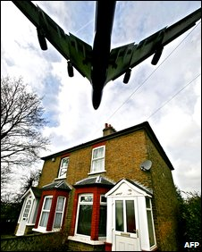
A third runway could mean an extra 200,000 flights a year over London.
Why should aviation capacity be increased indefinitely? At a time when most accept the need for emission cuts, say opponents, should we not stick with the capacity we have and allow market forces to price out inessential flyers?
• Health of Londoners at risk
A Greater London Authority (GLA) report suggested Heathrow would even now breach the EU regulations on levels of Nitrous Oxide due to come into force in 2010. Extra flights would only make this worse.
Even the Environment Agency admits that with a third runway, Heathrow would breach these limits.
The GLA study also found that the airport would breach noise pollution limits as a result of the extra flights.
• Economic case overstated
Many of the new passengers the extra runway would bring would be transit passengers. According to former BA boss Bob Ayling they would spend little or nothing in London, only boosting airline profits.
According to Sir David King, former chief scientific adviser to the government, the runway would over time come to be seen as a 'white elephant'.
Long before investment in it were repaid, demand for flying will have fallen away as pressure to reduce carbon increases and competition with other forms of travel grows. The downturn is already forcing people to find substitutes for air travel. This pattern will continue, he suggests.
• Impact on the local area
Transport infrastructure around Heathrow already struggles. The extra demands would create gridlock.
To make way for the runway, Sipson - a village of 700 houses - would be demolished and hundreds of acres of greenbelt land would be swallowed up.
• Alternatives
For historical reasons, Heathrow is badly located. It is the only major airport with flight paths over a large capital city, for instance.
Some, like London Mayor Boris Johnson, believe this is a perfect opportunity to start again and propose a new airport in the Thames Estuary.
Planes would approach and leave over water, reducing the impact of noise and the airport could operate 24 hours a day.

